Thursday Bidding Tips 15 Board 8 played on 6/9/2018 ClarkePairs
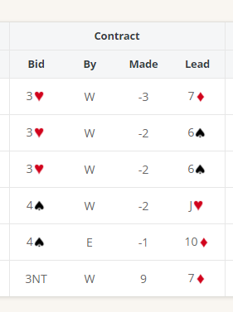
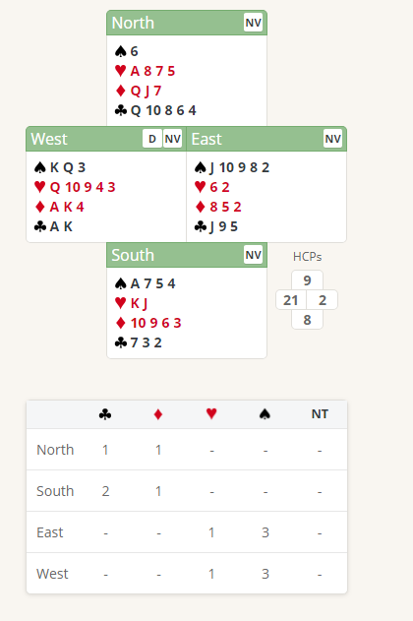

Suggested Bidding
N | E Dealer | S | W
 |  |  | 2C
Pass | 2D | Pass | 2H
Pass | Pass

- Wests Bid of 2 Clubs shows Either 20+ Distributional hand, game force Or 23+ Balanced hand, game force
- Easts 2 Diamonds shows 0-7 any shape, nothing to do with diamonds
- West Bids 2H showing 20+ 5+ card Heart suit
- East Passes with 2 points and 2 Hearts (shows a weak hand)
- All pass

Suggested Lead from South 6 Clubs (4th of strongest non trump suit) or 6 spades (singleton)
East West will likely go light.
Further notes about Strong Opening bidding
http://www.nzbridge.co.nz/user/inline/1649/NZB%20Beginner%2010%20-%20Student%20Notes.pdf

